Robots

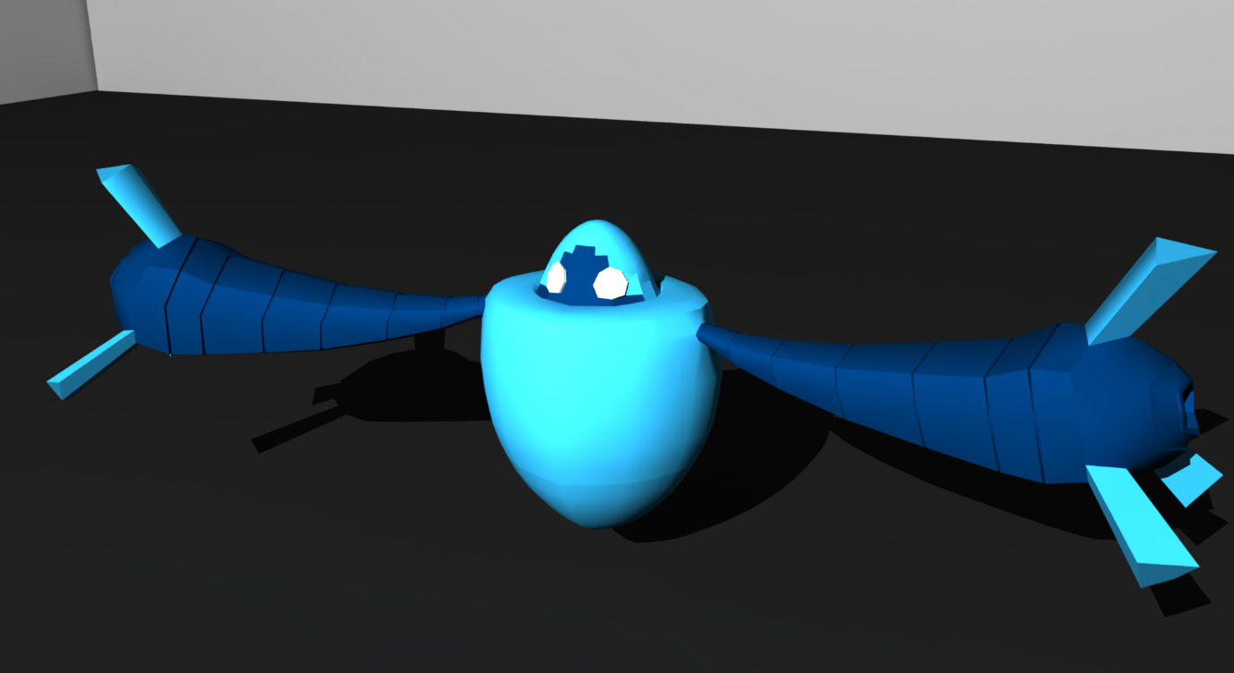

Contents

Introduction 3

Design 3

Description 3

Software 4

Narrative Description 4

Settings 4

Genre 5

Focal Points 5

Locations 5

Level Features 6

Usability, Gameplay Reference, and Research 6

Photo/Video Reference and Research 6

Architecture 6

Lighting 11

Inspiration 12

Story 13

Interactivity 13

Enemies 13

Set Pieces/Scripted Events 14

Visual Development 14

Style Reference 14

Colour Palette 16

Lighting 16

Top-Down Layout and Concept Art 17

A detailed top-down schematic of the entire level 17

Examples of concept art 18

Darwin 18

The Guard 19

The Warrior 20

The Flying Saucer 21

Screenshots from Unity showing blocked-out content 22

Uniqueness/Originality of the Level 23

Project Planning and Control 24

A detailed project plan starting from the date of the first class for the module, and containing all of the tasks and sub-tasks involved in the project 24

Tasks 24

Gantt Chart 26

A description of the process that you will adopt to monitor progress on the project 27

Source Control 27

Playtesting 27

Methodology 27

Questionnaire 28

Conclusion 29

References 29

# Introduction

This document will describe, in great detail, the design for a level in the game *Robots*. The game is a 3D third person platforming game where the player takes control of a robot, Darwin, as he escapes a prison ship. During the level, the player must defeat enemies by either punching them or jumping on their head, and avoid traps, in order to escape the prison ship.

# Design

## Description

The level takes place on a large prison ship somewhere in space. The player assumes control of a small robot, Darwin, who is a prisoner on the ship. The game begins with Darwin lying on a bed in his cell in the prison. However, after a few seconds, his cell door opens so he can escape.

The player is then free to begin exploring the level. Their first goal is to escape the prison area. Inside the prison area the player can see a lot of other robots who are trapped in cells. They can also run into prison guards, who will attack the player on site.

Once the player has escaped the prison area they will be on the hull of the ship. Differing from inside, this area will be very brightly lit and be much more open. When the player first enters this area, they overhear some guards talking about some ships in the hanger bay next to the radio tower. The player must then begin making their way towards the hanger bay in order to escape.

Once the player has made their way to the hanger bay, they will head back inside. The hanger bay will be more similar to the prison cells in term of design, with a lot more tight spaces the player must navigate. Inside the hanger bay, the player must fight enemies and make their way to a space ship which the player will use to escape the prison ship completely.

Once the player makes it to the ship to escape, a small cut scene is shown of them flying off into space. They are pursued by a lot of other ships, which are prison guards still trying to catch them. The level ends here.

## Software

* Unity
* Microsoft Word 2013
* Microsoft Excel 2013
* Git
* Github
* Audacity
* Visual Studio 2013

The game will be created mostly using the Unity game engine. The reason for choosing Unity, as opposed to another game engine like Unreal, is that Unity is a much simpler game engine that allows for very rapid iteration on the developers side. Unity is also much more familiar to the developer than Unreal, so the developer can spend less time focusing on learning a game engine and more time creating the game.

Source control will be handled through Git and Github. The reason git was chosen for source control, as opposed to Perforce or SVN, is because Git is free to download and it is free to set up a repository through Github. Perforce is commercial software that must be paid for, and SVN is more difficult to set up a repository for. Git, unlike SVN, also has an offline mode, which is very useful as the main developer is often without internet.

For audio, Audacity was chosen because it is a free piece of software, which also allows powerful editing of audio. It is also relatively simple to use.

## Narrative Description

You play as a small robot, Darwin, in a galaxy populated by robots. You were captured by mercenaries and are being transferred on their prison ship. On the way however, a mysterious force unlocks the gate to your cell, giving you a chance to escape.

## Settings

The game is set in a fictional galaxy, which is inhabited by robots. The only part of this the player will see, however, is a prison ship, which has robots prisoners and guards. Despite being set on a prison ship, the game is meant to come across as fun and light hearted, similar to a lot of platformer games from the PlayStation One and PlayStation Two era, like *Jak and Daxter* (Naughty Dog, 2001) or *Crash Bandicoot* (Naughty Dog, 1996).

## Genre

The game is a cartoon science-fiction 3D platforming game, set in a galaxy completely inhabited with robots. The story of the game follows a small robot, Darwin, who is held as a captive on a prison ship.

## Focal Points

In each of the three locations in the level, there is a different focal point guiding the player. These focal points are meant to keep the player going in the right direction. One of the reason for having in-game focal points do this, rather than having a mini-map or a large arrow pointing in the direction, is to avoid breaking the suspension-of-disbelief for the player. Having large UI which “magically” tells the player where to go can make the game less fun and ruin some of the exploration and problem solving for the player. Having large focal points serve the same purpose, integrating them into the game will make them less obvious and will keep the player engaged.

There is no definitive focal point for the prison area, guiding the player. Instead, they are told they have to get to the exit, and are encouraged to go the exit by following the, “Exit,” signs.

When the player is on the hull of the ship, the focal point guiding the player will be a large radio tower. The player overhears the hanger bay is next to a radio tower, so they know that’s the way to go.

Inside the hanger bay, the focal point will be the space ship that the player is trying to get to in order to escape. The space ship will be very obvious, using bright colours in order to stand out.

## Locations

There are three locations the player explores in the game. There are; the prison cell block, the hull of the ship, and the hanger bay.

The prison cell block has a lot of dark areas, with some sharp lighting contrasting it. This violent contrast is meant to signify the oppression the robots feel being in their cages.

The hull of the ship is much more open than the prison area, giving the player more room to move around. Having this freedom of movement is meant to signify, for Darwin, that he is free from prison, rather than being trapped. The lighting on the hull is also much brighter than in the cell block.

The final area, the hanger bay, is a mixture of both the prison cells and the hull. The hanger bay has a lot of sharp lighting, similar to the prison cells, which is meant to show some of the hopelessness of Darwin’s escape attempt. However, the areas are much larger and open like the hull, showing that he still has some hope.

## Level Features

The level will feature many things which are common among 3D platformers, though they will also be tied into the space theme in order to keep the suspension-of-disbelief alive for players. An example of this would be; there are “lava” pits the player has to jump over, since there is no lava on a spaceship. The pits are instead made of a red-hot metal, although they would serve the same gameplay mechanic.

In order to ease the player into the game, some of the earlier traps for the player will not kill them outright. If there is a hole the player must jump over, and the player is in the first half of the level, then falling into the pit will probably not kill them. If they fell into a similar pit later in the level, it would kill them and they would have to go back to the last checkpoint. This was done so that the player can have some trial-and-error when learning the mechanics of the game early on before the level becomes more difficult.

## Usability, Gameplay Reference, and Research

The player will control Darwin the robot through the use of the WASD keyboard keys. As Tyler Wilde, 2016, discusses, using the WASD is very common and intuitive for the players. The player will jump with the spacebar, and will punch by clicking the left button on the mouse.

* WASD – Move Darwin
* Mouse – Move camera
* Spacebar – Jump
* Left Click – Punch

There will also be support for Xbox 360 and Xbox One controllers. On these controls, the player will walk around using the left analogue stick, and move the camera with the right stick. The A button will make the player jump, and the X button to punch. Similar to the PC control layout, this was chosen because it feels very natural to do, and is very common with other 3D platformers, so the player will not get too confused when starting out.

* Left Stick – Move Darwin
* Right Stick – Move camera
* A – Jump
* X - Punch

# Photo/Video Reference and Research

## Architecture

The International Space Station, which was initially launched in 1998, was a large influence on how the prison ship would look. Even though *Robots* has a very cartoon-inspired style, it was important to ground some things in reality as much as possible, in order to keep the suspense-of-disbelief alive for the player when they play the game. The prison ship in *Robots* has a lot of solar panels to power the ship, much like the International Space Station.

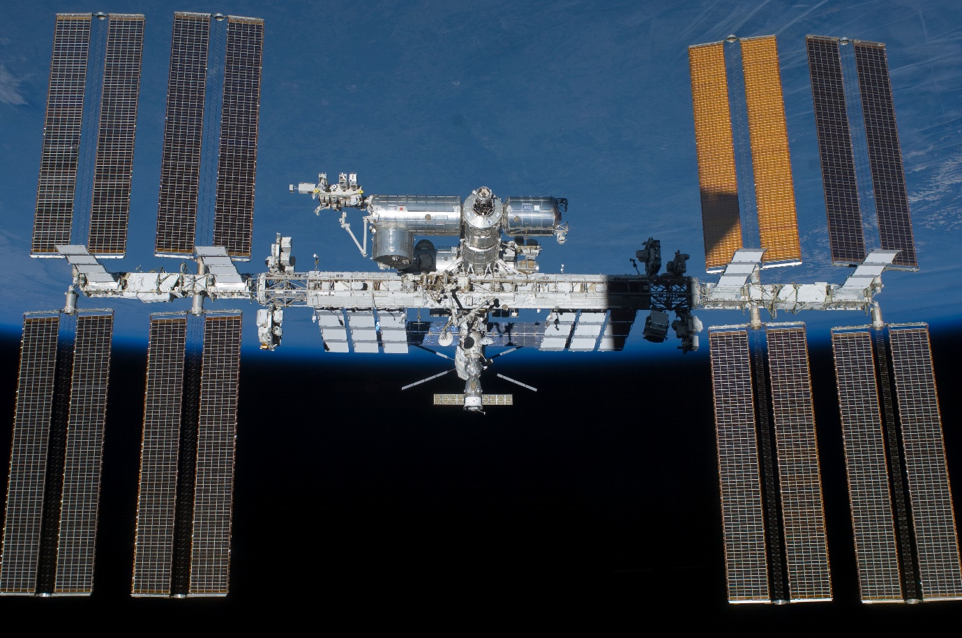

*International Space Station, NASA*

The *Purgatory Prison Ship* from the game *Mass Effect 2* (Bioware, 2010) also proved to be a large influence for designing the interior of the prison ship. The ship has a lot of sleek designs were the main inspiration, and is very similar to how the prison ship in *Robots* looks on the inside. The main reason for having a more sleek designed ship, rather than a more rustic one that may be more common for a prison ship, is because it helps with the light-hearted tone of the game. The game is not meant to evoke feelings of terror in the player, but meant to be a much more fun feeling game.

In *Mass Effect 2*, throughout the level, a red light flashes as the player makes their way through the ship. This was another reason the level inspired *Robots*, because we feel having a light flash during a breakout would add more immersion into the game.

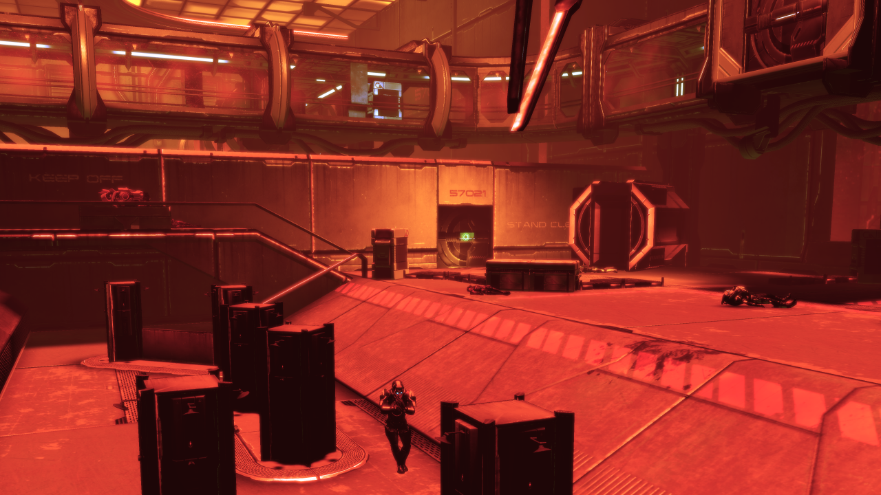

For the hull of the level, the main inspiration for the design was the *Star Destroyer* ship from *Star Wars* (Lucasfilm Ltd., 1997). The *Star Destroyer* ship, while looking very imposing, is also a very clean style. Most of the ship is very symmetrical, and it is created using simple shapes. The design lends itself very well to the simple design of *Robots*, as an overly complicated design would not fit with the overall style of the game.

Another point of inspiration was the *Control Bridge* at the top of the *Star Destroyer*. It is a large structure, which could be seen from any point on the hull, similar to the *Radio Tower* in *Robots*.

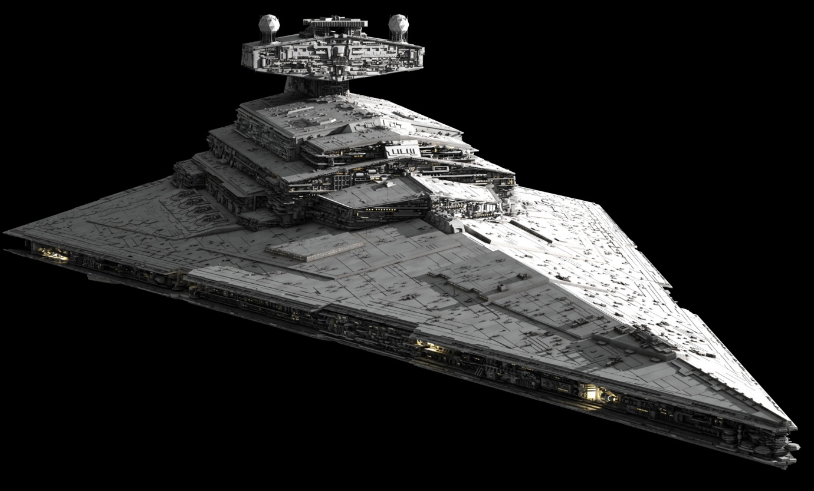

*Imperial Star Destroyer from Star Wars*

The final part of the level took inspiration from actual airport hangers. There were two reasons for this. The first is that we wanted the game to have a strong grounding in reality, despite its cartoon-like appearance and nature. This was so the player does not break suspension-of-disbelief while playing it. Another reason is that, from a gameplay perspective, the level had to be very open, giving the player freedom to explore it.

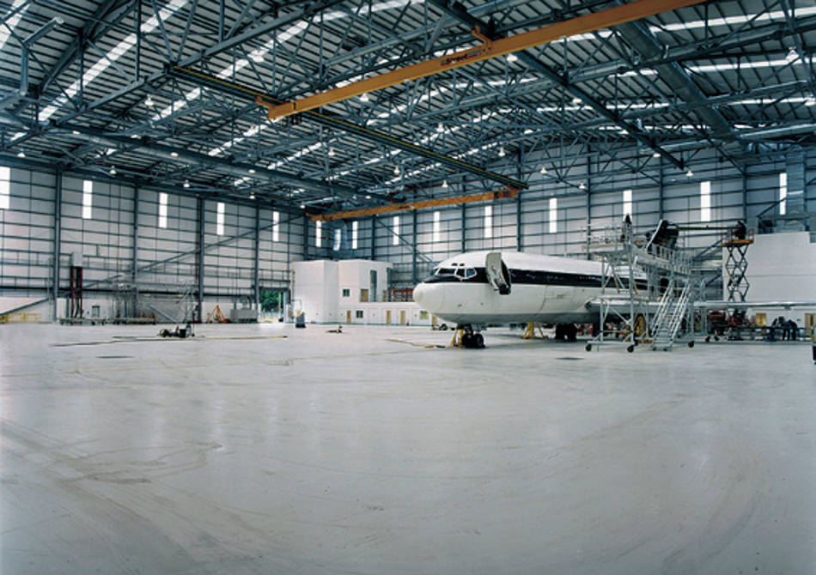

*MRO Hanger, Shannon Airport.*

Another inspiration for the *Hanger Bay* part of the level is the hangers from *Star Wars*. These hangers have a large “window” which you can see space through, and where the space ships fly through when leaving the ship. Because Darwin is trying to escape the ship, having a similar window, which could be viewed as a *portal* to finishing the level.

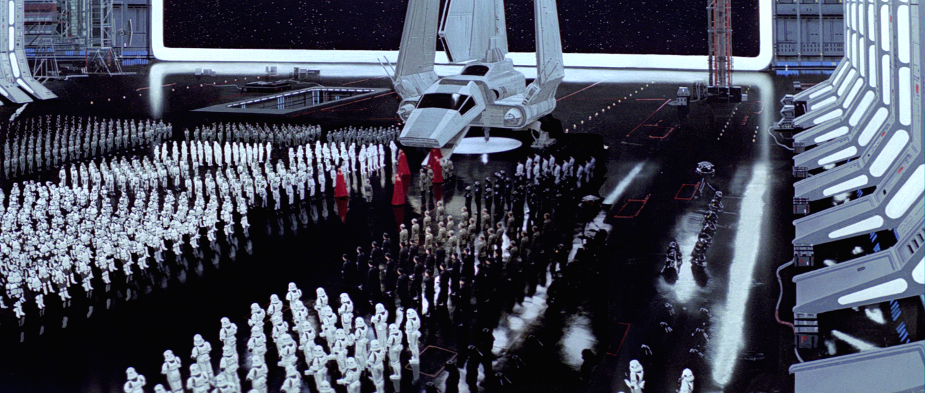

*Hanger Bay in Star Wars Episode IV: Return of the Jedi*

## Lighting

The lighting in the *Cell Block* section of the level took some inspiration from the film *Guardians of the Galaxy* (Marvel Studios, 2014). In one scene in the film, where the protagonist is in prison, the prison is shown to be very high-tech, but with a lot of sharp lighting. This helped amplify the sense of dread to the viewer, making them feel similar to the protagonist stuck in prison. A similar effect happens in *Robots*, when Darwin is in prison. The lighting in the prison section is much darker than other sections, which symbolizes Darwin’s hopelessness at being in prison; and helps the player empathise with what Darwin feels.

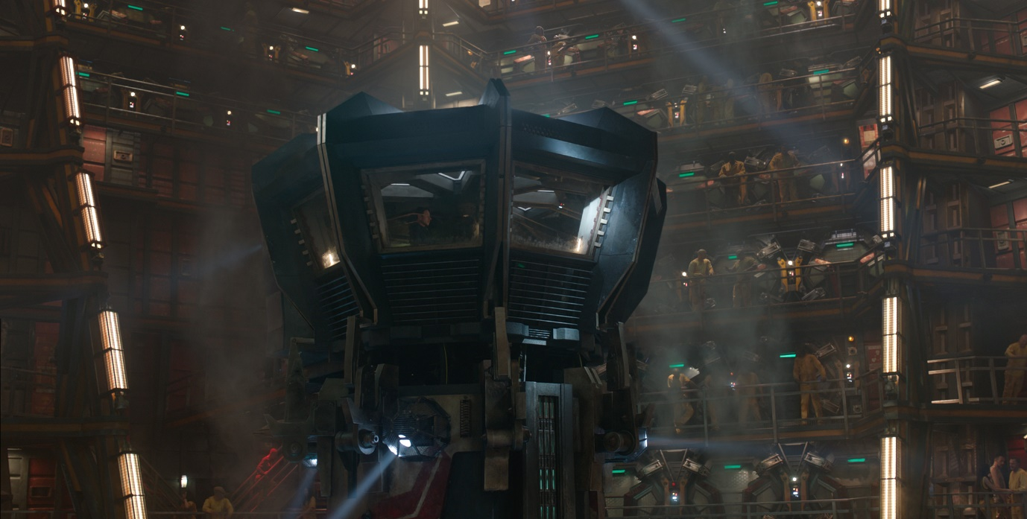

*Prison scene from Guardians of the Galaxy*

Further into the level, when the player is out on the hull of the ship, the level gets much brighter. A lot of the inspiration for this was taken from *NASA* footage of space walks. Because there is nothing obstructing the sun from reaching the hull of a ship in space, it is very bright and lit well. Making this choice was important for grounding the game in reality, so the player is not wondering why there is no light on the hull even though there should be. It also serves to mimic the Darwin’s feeling of hopefulness as he realises he might escape the prison.

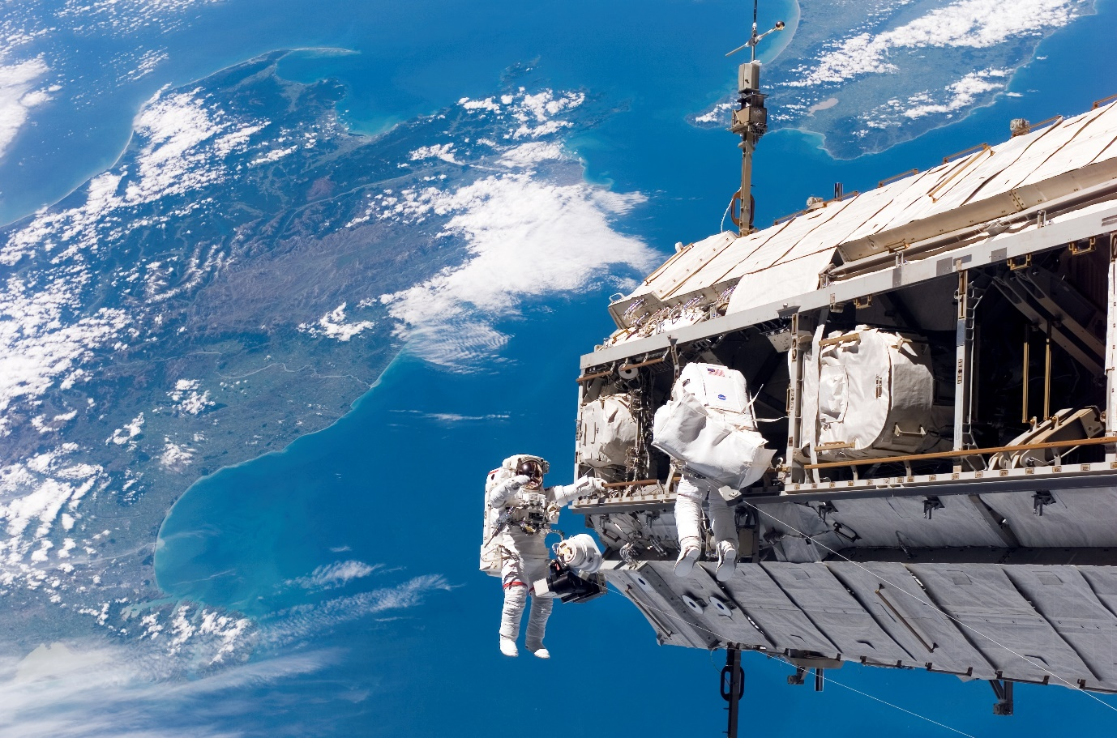

*A space walk, from NASA*

## Inspiration

A lot of inspiration came from *Ni No Kuni: Wrath of the White Witch* (Level 5, 2013). The characters in the game have very simple design, often consisting of just a few colours, but given the high quality of the models, it leads to very nice results. The characters end up being very reminiscent of early cartoons and it gives of a very warm, child-like feeling.

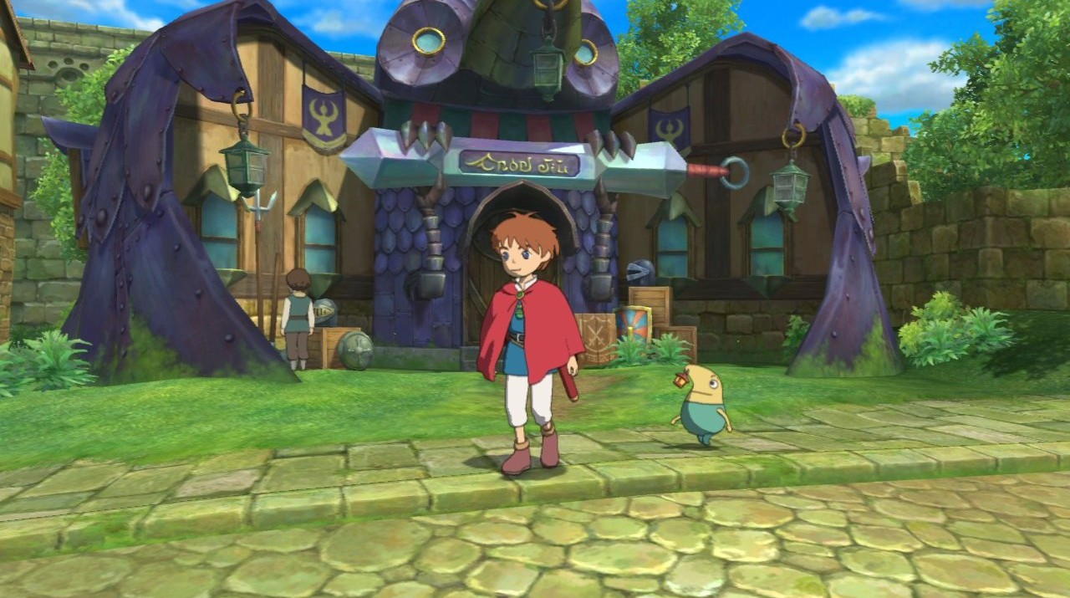

*Ni No Kuni: Wrath of the White Witch*

## Story

The story begins with Darwin sitting in a prison cell. The player is given no indication of why he was in a cell. This is because the story is not a core focus of the game, so only minimal hints of the story are given so the player does not focus their attention on it. Instead of telling the player the story outright, the player is encouraged to discover it themselves and piece together, in their head, how the story of the game and gameplay intertwine to reinforce each other (Fine, 2011).

After being in his cell for a few seconds, the cell doors open. Darwin then leaves the cell, and begins trying to escape to the outside of the ship. On his way to get outside, the robot guards attempt to stop him.

Once outside, on the hull of the ship, Darwin overhears two guards talking about the ships in the hanger, next to the large radio tower. Darwin then begins heading to the radio tower, and is confronted by a lot of guards on the way.

Once he is at the radio tower, he goes into the hanger bay next to it. He then fights off more guards, before stealing a space ship and flying off into space.

When Darwin is flying off into space, a lot of enemy ships are seen chasing him. Then the level ends, and the credits roll.

# Interactivity

## Enemies

There are main 3 enemy types in the level; and each enemy is divided up into a further 3 subtypes.

The first enemy type the player encounters is called *The Guard*, and they are the easier enemy in the game. The guard is very square looking robot, which runs on wheels. They also have claws which they use to hit the player. On the top of their head, they have a light which flashes blue like a police siren. The reason for the light is just to convey to the player that they are a prison guard. The light on their head is also a subtle hint to the player that they can be defeated by jumping on their head. They also have a large exclamation mark on their stomach, which is another subtle hint to the player that they can be killed by punching them.

The second enemy the player encounters is called *The Warrior*. Their design is meant to look like a small cartoon-y samurai. They have a sword in each arm, which they use to hit the player. On their head they have wicker bamboo hat on their head. This hat is large and pointed, which conveys to the player that *The Warrior* cannot be beaten by jumping on their head. If the player jumps on their head, they will just bounce. They can only be defeated by punching them.

The third and final enemy is called *The Flying Saucer*. They are a hovering enemy which look like a small stereotypical alien spaceship. They have a gun underneath he spaceship, which shoots bullets at the player. They have a small head sticking out of the top of the ship, which is meant to look like a target, and is similar to *The Guard’s* head. *The Flying Saucer* can only be beaten by jumping on their head. Because they float, they cannot be punched.

Each of the three enemies; The Guard, The Warrior, and The Flying Saucer, have three subtypes within them. The three subtypes represent different enemy difficulties; and can be distinguished by their colour. Green enemies are easier, orange are medium difficulty, and red are the hardest difficulty. The only difference between the enemy subtypes is how much health they have; green enemies die in one hit, orange die in two hits, and red die in three hits.

## Set Pieces/Scripted Events

There are a few different scripted events in the game, which only serve to further the story for the level.

The first event is the player character in their cell, with the camera panning around the player before control is given to the player. The reason for this is just to give the player a full portrait of Darwin before they begin controlling him. Just before control is given to the player, the doors to Darwin’s cell open, allowing him to escape.

The second scripted event occurs when the player leaves the Cell Block. The camera zooms in on two guards, who are talking about the hanger bay next to the radio tower. One of the guards is a *Guard*, and the other is a *Warrior*.The reason for this small cut scene is to tell the player where to go next; that they have to escape the prison ship by going to the hanger bay and escaping on a ship. It also serves to introduce the second enemy type, *The Warrior*, to the player.

The third scripted event happens when the player enters the hanger bay. The camera is shown to zoom in on a ship in the hanger bay, highlighting to the player that this is the ship they need to use in order to escape the prison ship. Just before the cut scene ends, the final enemy type, *The Flying Saucer*, is shown approaching the player. This introduces the enemy to the player.

Once the player has reached the ship, the level is finished. A final cut scene plays, which shows the player flying off in the ship they stole. They are then shown to be chased by a lot of other ships, which are guards pursuing them. The game ends there, and fades to credits.

# Visual Development

## Style Reference

The game will use a simple cel-shading style in order to appear more like a cartoon. The game takes a lot of inspiration from *Ni No Kuni: Wrath of the White Witch* (Level 5, 2013).The gameuses cel-shading in order to make the game feel more like a cartoon and help the player enjoy the world.

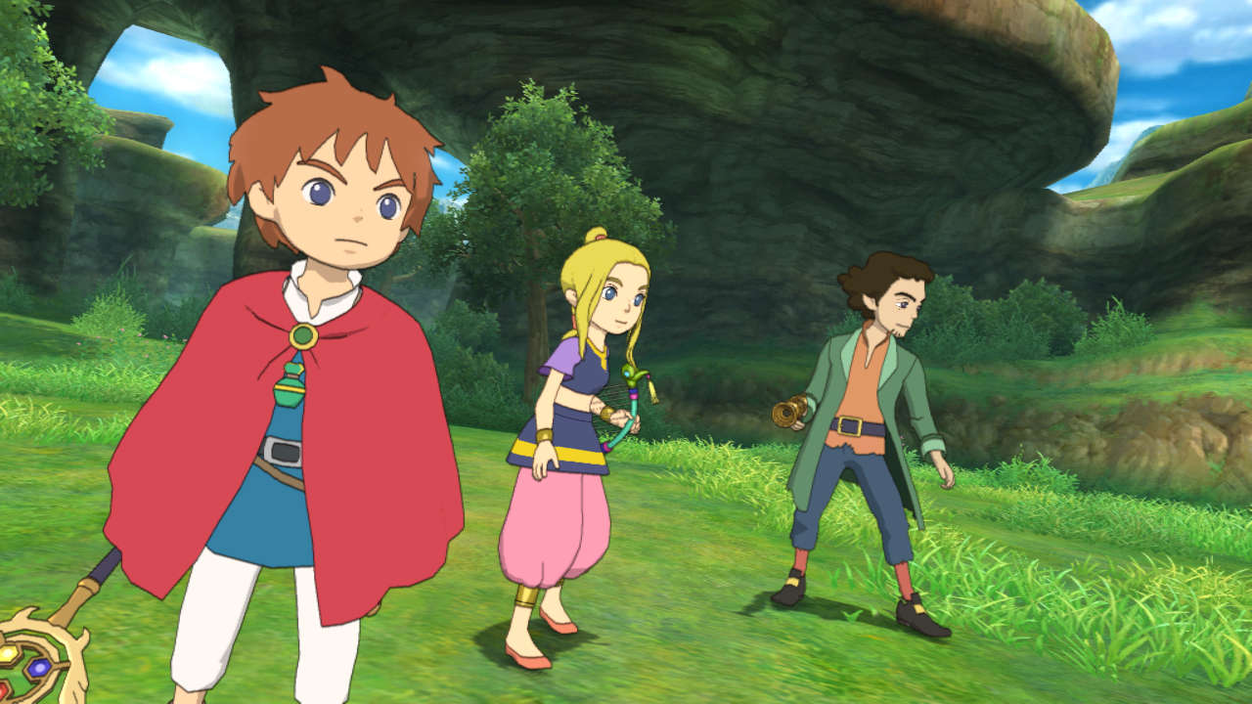

*Ni No Kuni: Wrath of the Witch Witch*

Another game that was a large influence on the style was *Ratchet and Clank* (Insomniac Games, 2002). *Ratchet and Clank* are 3D platforming games set on a mixture of planets and space stations. The games have unique art style, in which a lot of the environment is very tongue-in-cheek, and doesn’t take itself seriously. *Robots* was heavily inspired by this design.

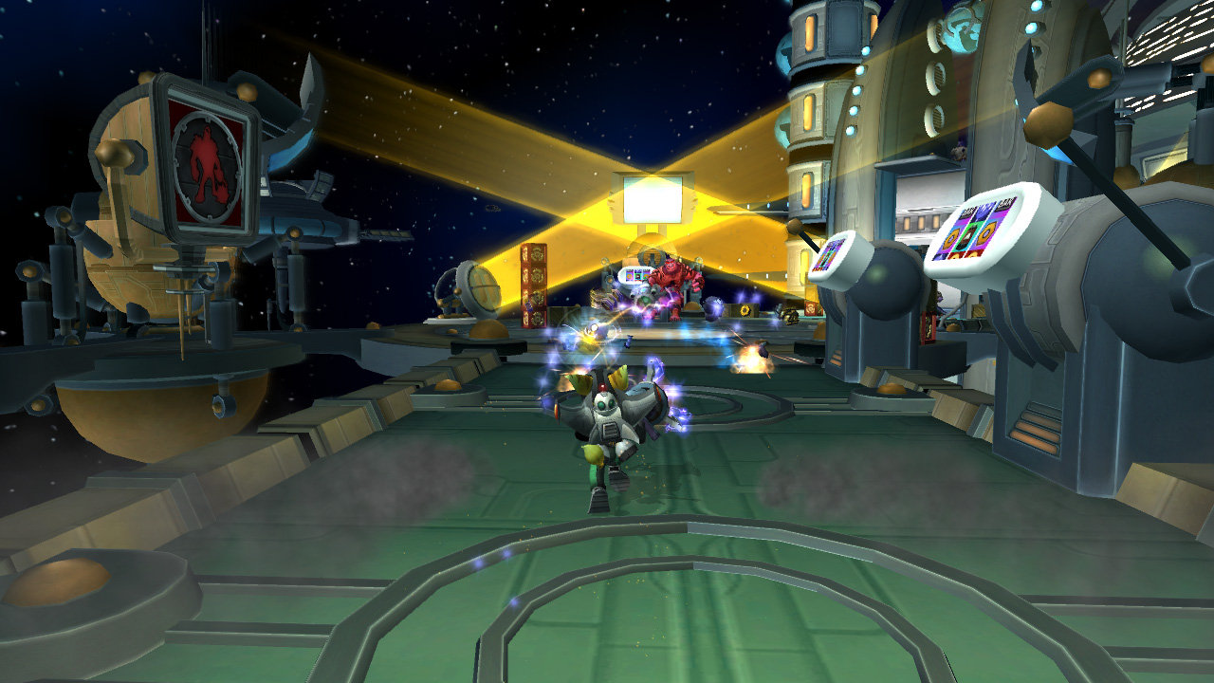

*Ratchet and Clank 2: Locked and Loaded*

## Colour Palette

The characters in the game are all made of strong colours which are bright and stand out, in order to make sure that they can be seen. For example; Darwin is blue, and the enemies are all red, orange, or green. This contrasts with the environment, which will be a much duller shades of grey and black that the environment is created from.

## Lighting

Lighting plays a very important role in *Robots*, as it is one of the primary mechanisms used to subtly guide the player through the level. Doors that the player can go through, and paths that the player can take, will be lit up much brighter than dead ends. This subtle detail is meant to help guide the player through the level (Millington, 2016). It is important because the level will not be as much fun if the player keeps getting lost or heading towards dead ends.

Lighting also serves another purpose in the game; it is one of the ways in which the levels of the game are differentiated. In the first section of the game, *The Cell Block*, the lighting is very dark and gloomy, reflecting the mood of all the inhabitants of the prison.

In the second area, *The Hull*, the lighting is much brighter, which is meant to give the player a much more uplifting feeling. This feeling mimics Darwin’s feelings about escaping the Prison Ship. Another reason that the lighting is much brighter on the hull of the ship, compared to inside, is because the lighting is unobstructed on the hull, so the sun can completely shine upon it. Inside the ship, however, the lighting is limited by the walls and roof.

The third area of the ship, *The Hanger Bay*, has lighting similar to the *Prison Cells*. This is meant to symbolize Darwin’s struggle as he begins to lose hope of escaping. The brightest light in this area is shining directly above the ship that Darwin will use to escape, showing that the ship is his last hope.

As Darwin flies off into the distance at the end of the game, his ship is shown to fly towards the sun, which references his hopefulness at escaping again.

# Top-Down Layout and Concept Art

## A detailed top-down schematic of the entire level

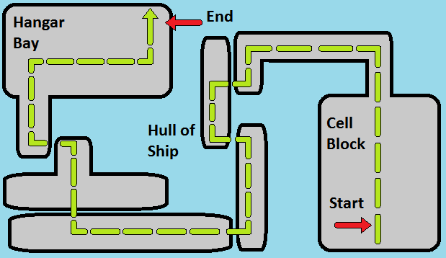

## Examples of concept art

All of the concept art for Robots was done by Lauren Martin.

### Darwin

The first two sketches show the main character, Darwin. The first image are some rough sketches which were when his initial design was still being decided upon. The second image is the final design that was chosen.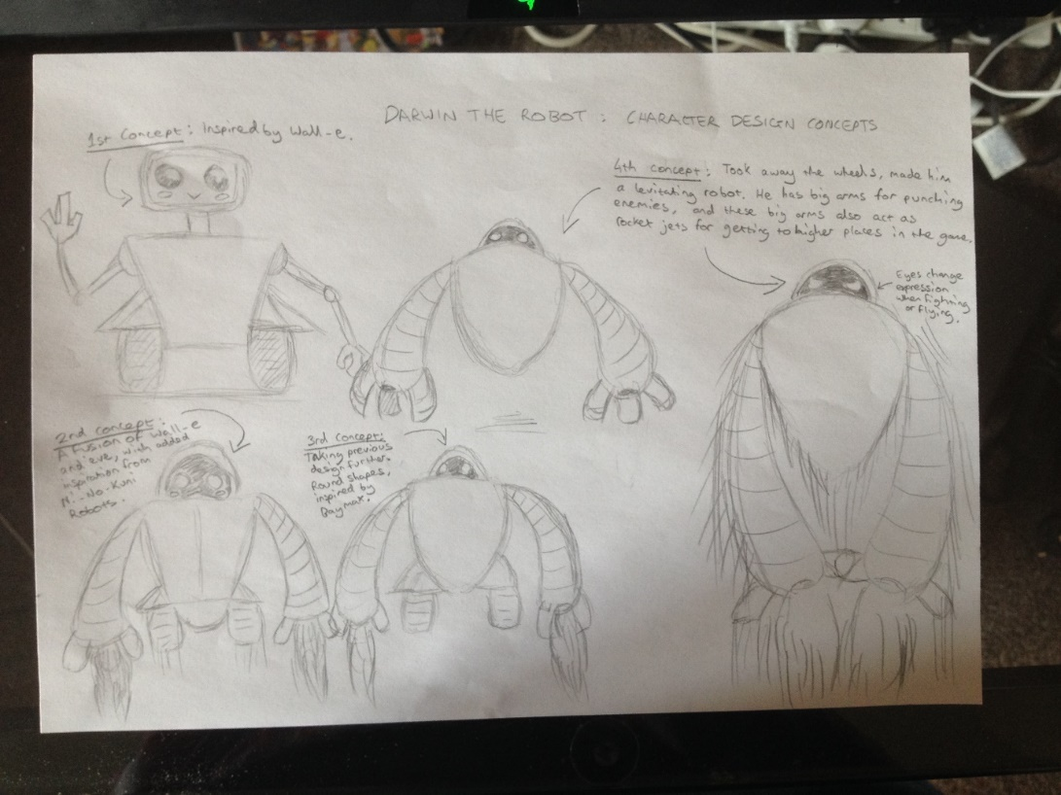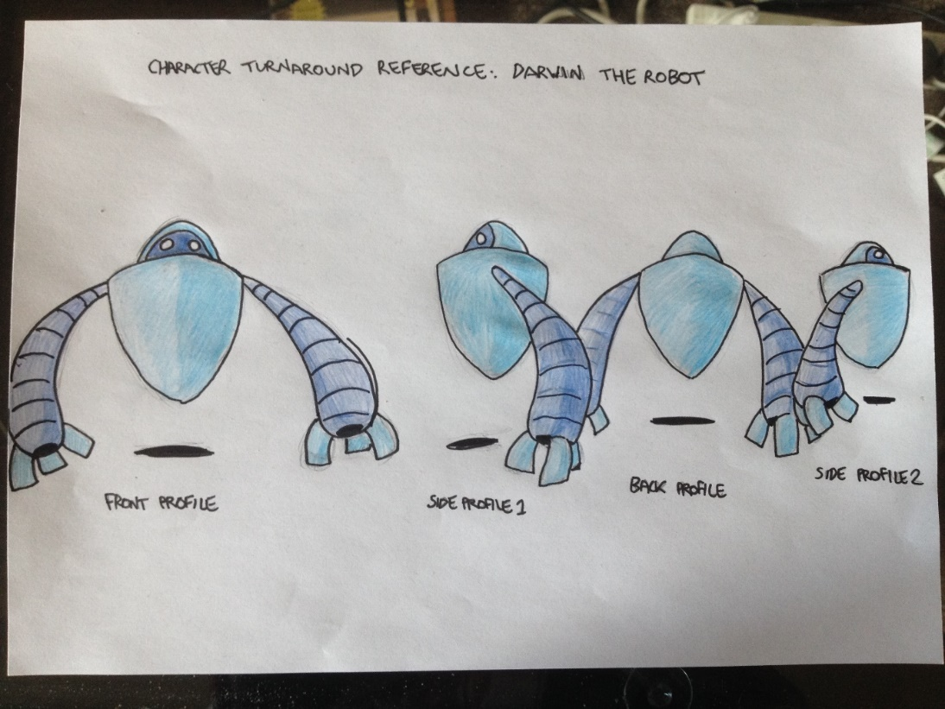

### The Guard

This is an image of the first enemy encountered in the game, The Guard. He can be beaten by either punching him, or jumping on his head. They come in three colours; green, orange and red. Each colour corresponds to how difficult that particular instance of the enemy will be.

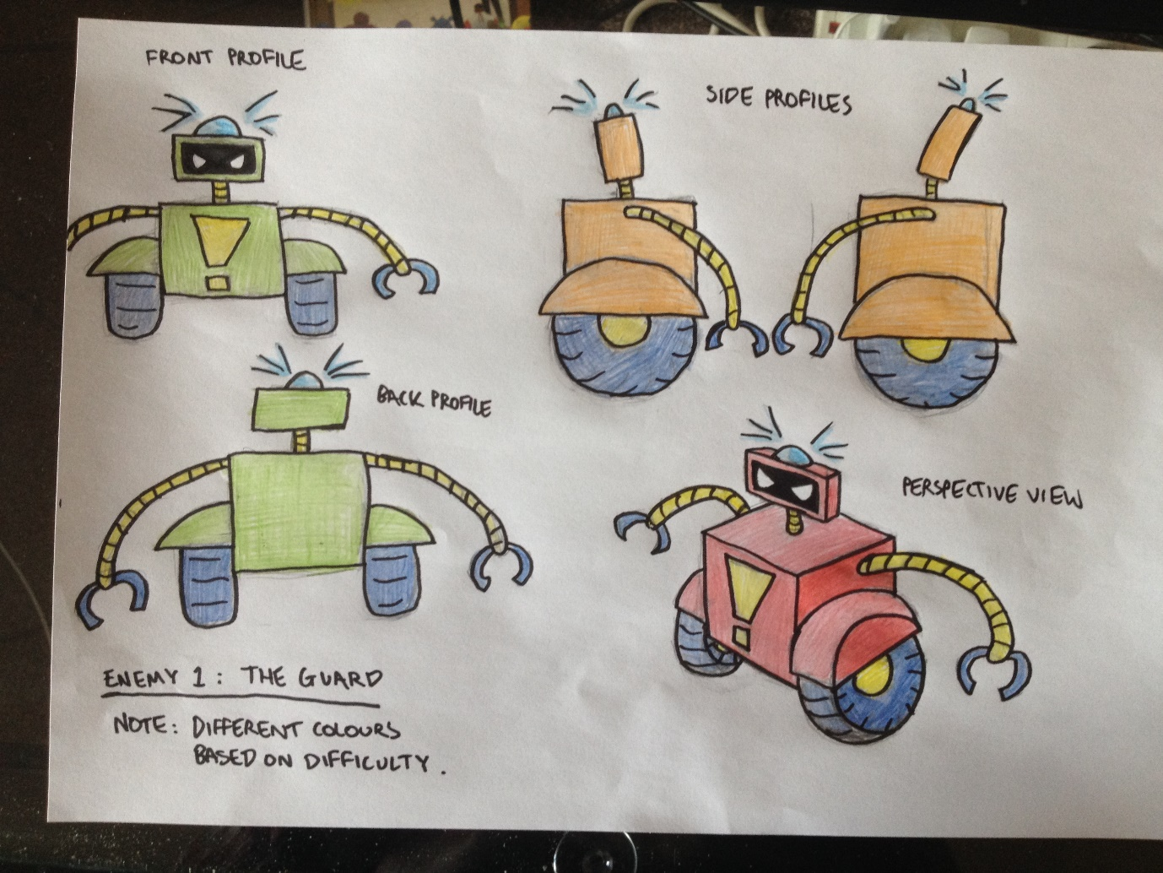

### The Warrior

This is the second enemy the player encounters in the game, The Warrior. They attack the player with both of their swords, and can only be killed by punching them. Jumping on their head does not affect them. They come in three colours; green, orange and red. Each colour corresponds to how difficult that particular instance of the enemy will be.

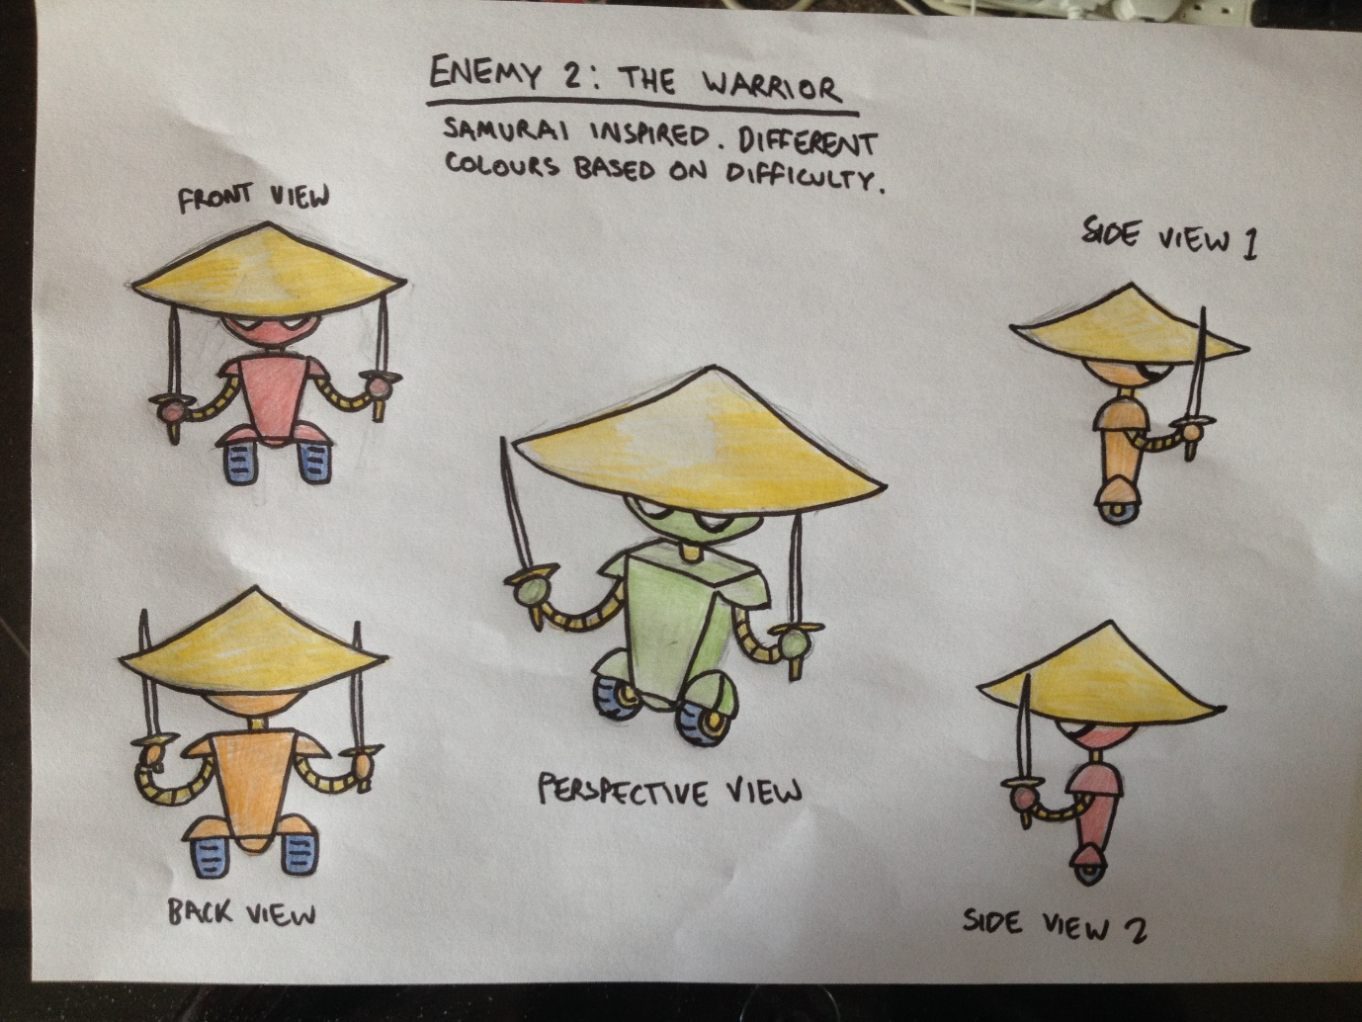

### The Flying Saucer

This is the third and final enemy the player encounters, The Flying Saucer. They attack by shooting the player with a gun they have mounted underneath themselves. They can only be defeated by jumping on their head, because they hover above the ground they cannot be punched. They come in three colours; green, orange and red. Each colour corresponds to how difficult that particular instance of the enemy will be.

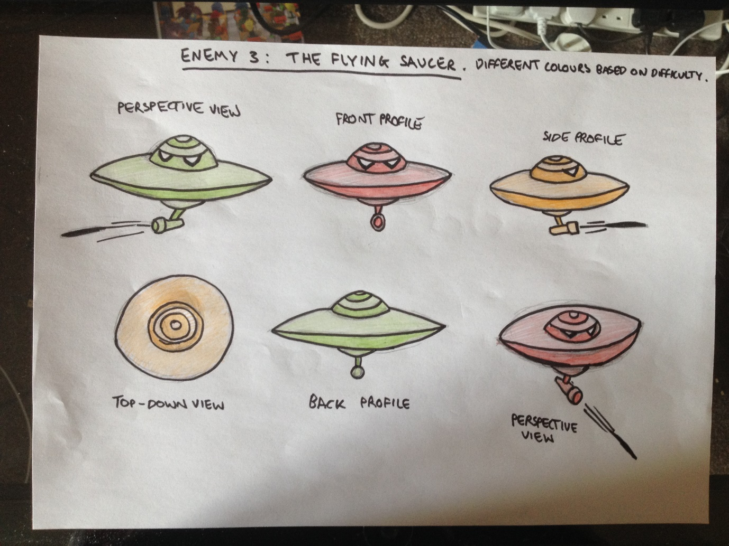

## Screenshots from Unity showing blocked-out content

The following three images are models of the main character, Darwin. The models were created by Lauren Martin.



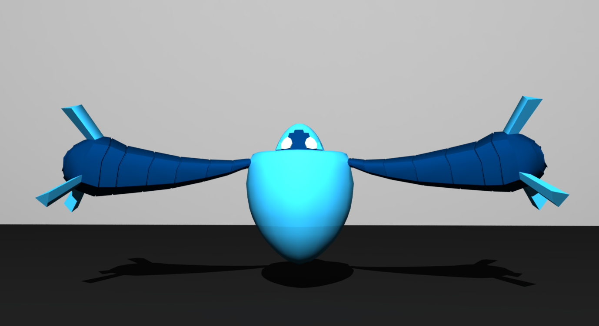

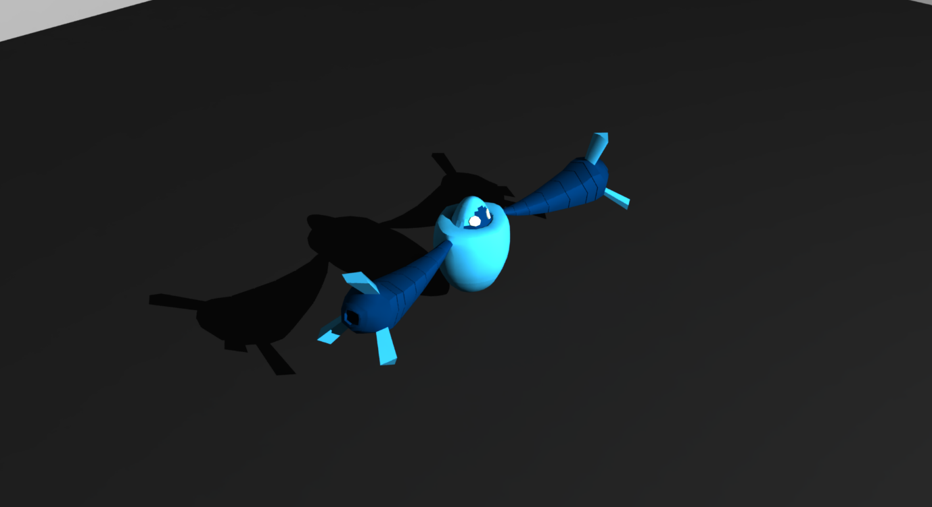

## Uniqueness/Originality of the Level

A lot of the originality of the level comes from the fact the game is a combination of classic 3D platformer games, like *Crash Bandicoot* and *Ratchet and Clank*, but combined with modern game design sensibilities. In recent years, game design has progressed a lot in terms of usability.

An example of this is; when the player dies they instantly respawn at the previous checkpoint. There are no lives, and the player can die as many times as they want, as they try and complete the level. This allows the player to keep trying difficult segments of the level over and over again as they try and complete it. It also encourages the player to play with the game mechanics a little, without fear of dying and having to restart the entire level again. The inspiration for this was taken from *Super Meat Boy* (Team Meat, 2010), in which the player instantly respawns when they die and have infinite lives, allowing them to experiment when completing levels.

# Project Planning and Control

## A detailed project plan starting from the date of the first class for the module, and containing all of the tasks and sub-tasks involved in the project

The project is split up into three stages; creating the document, developing and implementing the level, and testing the level.

The first stage, creating the document, took place from weeks 1 to 7, and involved creating the design document for the game. It also involved getting reference material, planning what the game would look like, as well as the characters in it.

The second stage, developing the level, will start around week 4 and will finish around week 9. In this stage, I will begin adding the assets created for the game into Unity, as well as creating out a more final level.

The third and final stage, testing, will begin in week 9, and will continue through until week 12. In this stage, I will have as many as possible people complete the game, and will have them fill out survey after completing it, in order to gauge what worked well in the game, and what needs improvement.

## Tasks

The three sections are each divided up into smaller, more manageable chunks.

1. Level Design Document
   1. Setting
   2. Theme
   3. Focal Points
   4. Locations
   5. Level Features
   6. Usability and Gameplay Reference and Research
   7. Photo/Video Reference and Research
   8. Lighting
   9. Inspiration
   10. Story
   11. Controls
   12. Enemies
2. Development
   1. Block out level
   2. Create static assets
   3. Create player model
   4. Create enemy models
   5. Create enemy scripts
   6. Create obstacles
   7. Create scenery textures
   8. Setup lighting
3. Testing
   1. In-House testing
   2. Beta user testing
   3. Alpha user testing
   4. Formal evaluation

## Gantt Chart

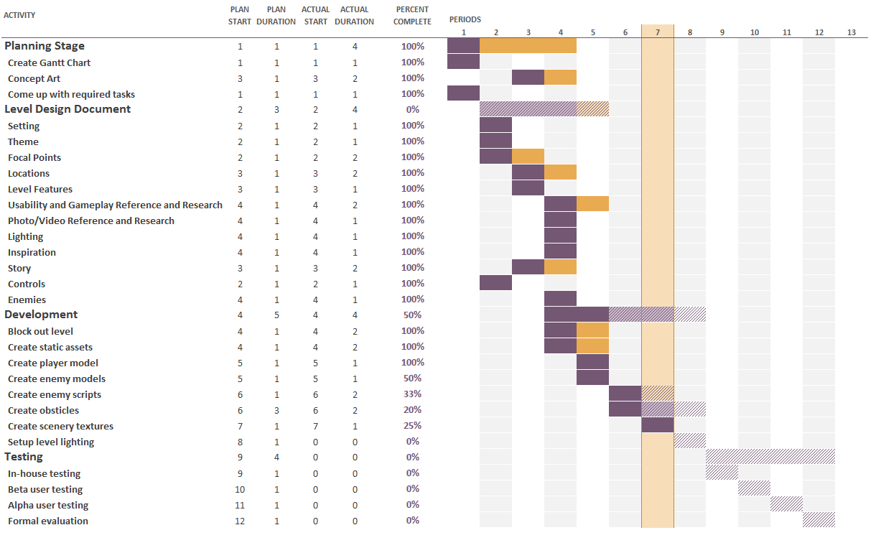

## A description of the process that you will adopt to monitor progress on the project

The project has taken a very agile-orientated approach to development. All of the tasks required to complete the project have been broken up, and then have had a week assigned to them. This means that the developers know if they’re falling behind or are on time, because they can simply compare to see if they’ve done all the tasks they should have to be on schedule.

## Source Control

Throughout development, the game will be constantly backed up using *Git* version control, to a server on the *Github* website. The reason we are using source control, is so that large changes can be made to the game without worrying that it will end up with a broken build and no way to get it working again. The development style of the game will focus on a lot of small commits, which will allow the game to be reversed to almost any state during development. This will also make it easy to see when bugs were introduced, which is important for developing a style which avoids them.

# Playtesting

## Methodology

In order to make sure that the level is fun to the player, and there are no game-breaking bugs, I will attempt to get as much feedback as possible. The main way I plan to get this feedback is by observing people play the game, and then present them with a questionnaire sheet at the end.

## Questionnaire

1. On a scale from 1 to 5, with 1 being you did not enjoy the level design at all, and 5 being you really enjoyed it, what rating would you give the level design?
2. On a scale from 1 to 5, with 1 being that you did not find the game fun at all, and 5 being that you found the game very fun, how fun was the game
3. On a scale from 1 to 5, with 1 being that you did not like the character models, and 5 being that you loved the character models, how would you rate the character models?
4. On a scale from 1 to 5, with 1 being that you did not enjoy the environments design, and 5 being that you loved the environments design, how would you rate the environment?
5. On a scale from 1 to 5, with 1 being that you found the controls difficult, and 5 being you had no issues with the controls, how would you rate the control scheme?
6. Answering simply Yes or No, would you recommend the game to a friend?
7. Answering simply Yes or No, if the demo was extended to a full game, would you be interested in playing it?
8. Answering simply Yes or No, did the lack-of story hinder your enjoyment of the game, or did you find it added to your enjoyment.
9. Please describe what would you thought the most enjoyable part of the game was.
10. Please describe what you thought the least enjoyable part of the game was.

# Conclusion

As you can see from this document, the game proposed, Robots, is very well thought out and could easily be expanded to a complete game. While it will take a lot of work to complete, we feel confident we can do it and create a very interesting and well thought-out level.

# References

Crash Bandicoot (1996). [Video Game, PlayStation] Naughty Dog, Sony Computer Entertainment.

Fine, R. 2011, April. Opinion: Play, Don’t Show. Available:

<http://www.gamasutra.com/view/news/124172/Opinion_Play_Dont_Show.php>

Guardians of the Galaxy (2014) [Film, 12+] Marvel Studios, Walk Disney Studios Motion Pictures

International Space Station (2006) [Image] NASA. Available:

<https://www.nasa.gov/sites/default/files/thumbnails/image/final_configuration_of_iss.jpg>

International Space Station (2006) [Image] NASA. Available:

<https://upload.wikimedia.org/wikipedia/commons/8/89/STS-116_spacewalk_1.jpg>

Jak and Daxter: The Precursor Legacy (2001). [Video Game, PlayStation 2, 12+] Naughty Dog, Sony Computer Entertainment

Mass Effect 2 (2010) [Video Game, Microsoft Windows, Xbox 360, PlayStation 3, 15+] BioWare, Electronic Arts

Millington, S. 2016. In Game Lighting: Does Lighting Influence Player Interaction and Emotion in an Environment?

MRO Hangar, Shannon Airport (2002) [Image] Dublin Airport Authority. Available:

<http://www.garlandconsultancy.com/assets/media/Images/Galleries/MRO%20Hangar,%20Shannon%20Airport/MRO-02.jpg>

Ni No Kuni: Wrath of the White Witch (2013) [Video Game, PlayStation 3, 12+] Level 5, Bandai Namco Games

Ratchet and Clank (2002). [Video Game, PlayStation 2, PlayStation 3 (HD), PlayStation Video (HD), 3+] Insomniac Games, Sony Computer Entertainment

Ratchet and Clank 2: Locked and Loaded (2003). [Video Game, PlayStation 2, PlayStation 3 (HD), PlayStation Video (HD), 3+] Insomniac Games, Sony Computer Entertainment

Super Meat Boy (2010). [Video Game, Xbox 360, Microsoft Windows, OS X, Linux, PlayStation 4, PlayStation Vita, Wii U, Android,12+] Team Meat, Team Meat.

Star wars: Episode IV – A New Hope (1997) [Film, U] Lucasfilm, Ltd., 20th Century Fox

Star Wars: Episode V – The Empire Strikes Back (1980) [Film, U] Lucasfilm Ltd., 20th Century Fox

Star Wars: Episode VI – Return of the Jedi (1983) [Film, U] Lucasfilm Ltd., 20th Century Fox

Wilde, T. 2016, June. How WASD became the standard PC control scheme. Available:

<http://www.pcgamer.com/how-wasd-became-the-standard-pc-control-scheme/>